

**Course code: 4170207**

**Software Engineering Theory**

Phase 2: Software Design Document

Team Name

Full Name ID

Rowan Alaa El-Din Abd El-Megid 203048

Sandra Samy Noshey 203054

Dec 2020

**Software Design Document**

Month & Year

**Contents**

Instructions…………………………..............................................................................................................................3

Team ...................................................................................................................................................................3

Document Purpose and Audience ......................................................................................................................3

System Models ...................................................................................................................................................4

II. Class diagrams ............................................................................................................................................4

III. Sequence diagrams....................................................................................................................................5

Class - Sequence Usage Table.....................................................................................................................7

IV. Physical Entity-Relationship Diagram........................................................................................................8

V. User Interface Design .................................................................................................................................8

VI. Algorithms and Data Structures ..............................................................................................................10

Ownership Report ............................................................................................................................................10

Policy Regarding Plagiarism:.............................................................................................................................10

**Software Design Document**

**Team**

|  |  |  |  |
| --- | --- | --- | --- |
| **ID** | **Name** | **Email** | **Mobile** |
| 1 | Rowan Alaa El-Din Abd El-Megid | sim.rawanalaaeldin3048@alexu.edu.eg | 01004213823 |
| 2 | Sandra Samy Noshey | sim.sandrasamy3054@alexu.edu.eg | 01278496736 |

**Document Purpose and Audience**

• **Any document anywhere should tell us 2 things: (1) what this document is and (2) who is expected to read it.**

• **Write in simple notes: What is this document?**

• **List the target audience to read this document (e.g. CEO? Project Manager? Customer...?)**

**Software Design Document**

**System Models**

**I. Class diagrams**

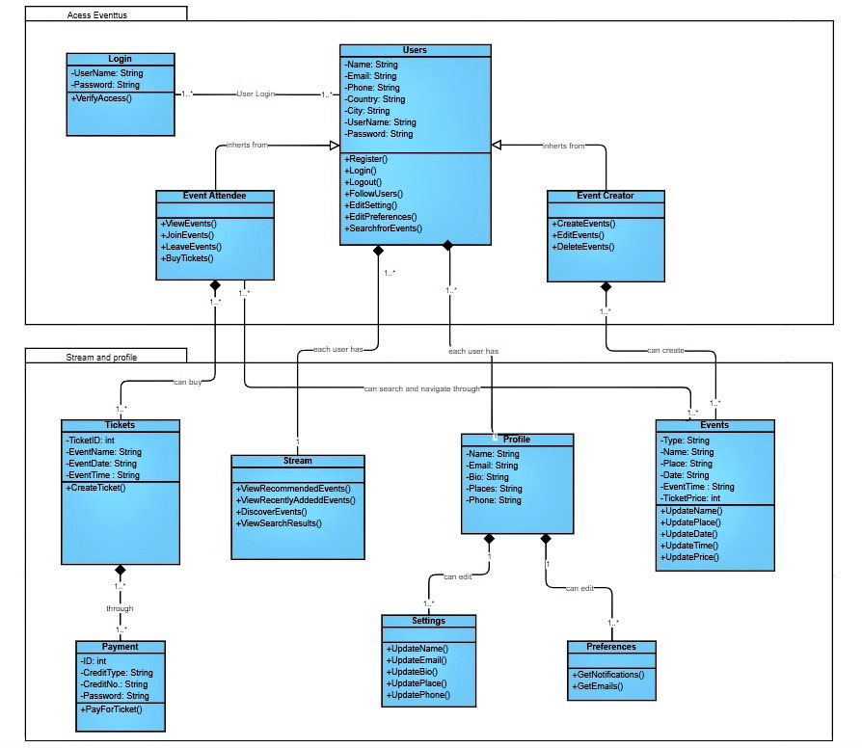

|  |  |  |  |
| --- | --- | --- | --- |
| **Class ID** | **Class Name** | **Subsystem ID** | **Description & Responsibility** |
| 1 | Login | 1 | It lets the users login in into the website by entering their usernames and passwords. |
| 2 | Users | 1 | It is the parent class of event attendee and event creator it contains their information and some of their functions. |
| 3 | Event Attendee | 1 | It is a child class from Users it contains the functions which the event attendee can only do. |
| 4 | Event Creator | 1 | It is a child class from Users it contains the functions which the event creator can only do. |
| 5 | Profile | 2 | It lets all the users to display their information and you can access settings and preferences. |
| 6 | Settings | 2 | It lets the users to update their information through it. |
| 7 | Preferences | 2 | It lets the users to edit what notification and emails they will receive from whom through it. |
| 8 | Events | 2 | It lets the event creators to create different events with different types and can edit it. |
| 9 | Tickets | 2 | It create tickets for the event you want to attend. |
| 10 | Payment | 2 | It is responsible for the payment process. |
| 11 | Stream | 2 | It lets the users navigates through the recommended events, recently added events, discover new events and view the search result. |

**I. Sequence diagrams**

1:

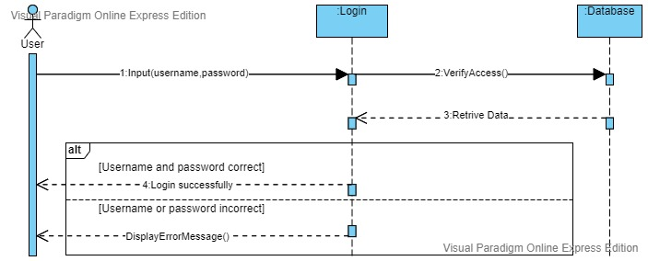

2:

3:

4:

**Class - Sequence Usage Table**

|  |  |  |
| --- | --- | --- |
| **Class Name** | **Sequence Diagrams** | **Overall used methods** |
| Login | 1 | Input(username,password),VerifyAccess(),DisplayErrorMessage(). |
| Users |  |  |
| Event Attendee | 3 | ViewEvents(), JoinEvents(), BuyTickets(), DisplayErrorMessage() |
| Event Creator | 2 | CreateEvents(),ManageEvents(),EditEvents(),DeleteEvents(),DisplayMessage() |
| Profile |  |  |
| Settings |  |  |
| Preferences |  |  |
| Events |  |  |
| Tickets | 3 | CreateTicket(), DisplayErrorMessage() |
| Payment | 3 | PayForTicket() |
| Stream | 4 | ViewRecommendedEvents(), ViewRecentlyAddedEvents(), DiscoverEvents(),ViewSearchResults() |

**Software Design Document**

**III. Physical Entity-Relationship Diagram**

• **Provide the ERD Diagram**

• **All entity classes on the class diagram that need to be stored permanently, convert them and their relationships into ERD diagram.**

•  **Don’t li s t any boundary or control entities!**

• **Use a suitable notation for representing ER diagram, e.g., the one proposed on the book or an alternative version. Build it using a tool.**

• **Following is an example of ER diagram, using different notation.**

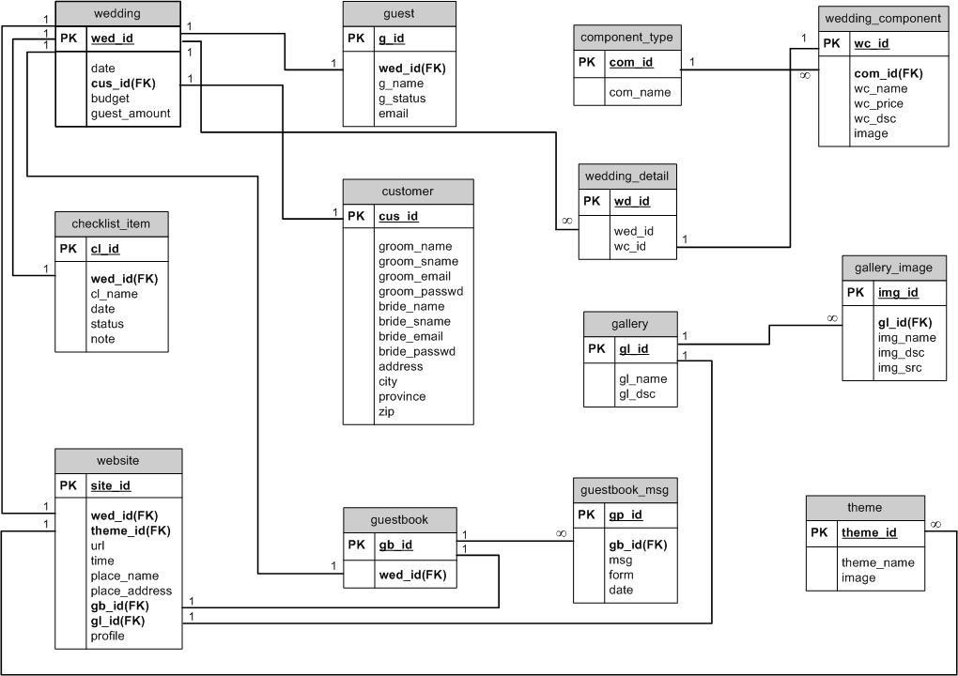

**IV. User Interface Design**

• **Use a prototyping tool like** [**https://app.moqups.com**,](https://app.moqups.com/) [**http://Infragistics.com o**](http://infragistics.com/)**r NinjaMock or using a GUI builder (like the one in NetBeans) to build your interface.**

• **Develop a prototype for each screen / page that your application will have and relate them to each other showing which one leads to which one.**

**Software Design Document**

• **For each screen specify the buttons, menus, etc. that will be on it and their functions.**

• **An example is shown below.**

• **Screen 1 – Login Screen (example)**

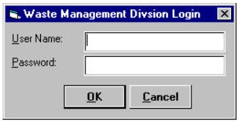

• **Screen 2 – Main Interface (example)**

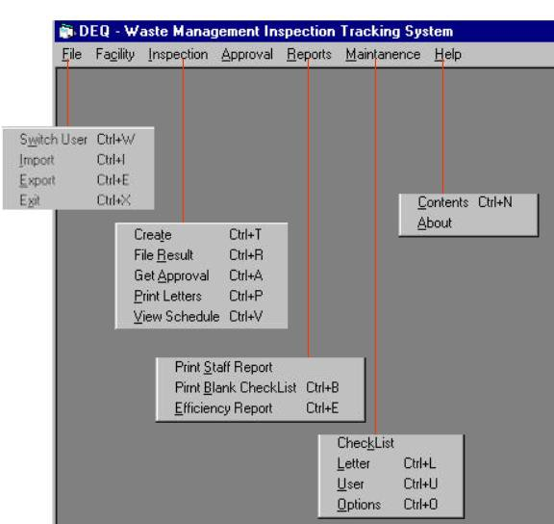

• **Navigation tree: Login Screen**

**|**

**Main Screen**

**Software Design Document**

**V. Dataflow diagram (DFD)**

• **Provide the DFD**

**VI. Algorithms and Data Structures**

• **Specify what algorithms you need in order to build the application. If it is an existing one, just refer to it. If it is one you will develop, then write in detail in mathematical notation, pseudo code, or as a flowchart. Example of such algorithms:**

o **the steps for calculating if there is winner in a two-player game.**

o **the steps for calculating the salary in a payroll program.**

o **the algorithm for deciding which posts to show first in a social network application.**

• **Specify which data structures (DS) you will use to store which data in memory, other than regular arrays and array lists. Justify your choice and explain the reasons behind it.**

• **In the rare occasion that no existing data structures supports your requirements, and you need to create a new one or implement a non-implemented one, include the design of this new DS.**

**Ownership Report**

• **Remove the following notes and any red notes**

• **For every item in this document, write the owners. If someone is owner of something, s/he understands it 100.%**

• **Team leader must verify the table with the team members.**

|  |  |
| --- | --- |
| **Item** | **Owners** |
|  |  |
|  |  |

Policy Regarding Plagiarism**:**

**Students have collective ownership and responsibility of their project. Any violation of academic honesty will have severe consequences and punishment for ALL team members.**

ةميلس ةيميلعت ةيلمعل ايرهوج اذه ربتعي ثيح بلاطلا تاشقانم و تامولعملا لدابت و راكفلأا ةشقانم ىلع ةيلكلا عجشت .1

.اشغ ربتعي و لوبقم ريغ لولحلا لدابت نكل و دوكلا ىف مهلكاشم مهل لح و عيطتست ام ردق ىلع كءلامز دعاس .2

.شغلاب اماق دق امهيبحاص نأ ربتعيس ردصملا سفن نم نلاوقنم امهنأب عطقت ةجردب رخآ لح ىأ عم هباشتي لح ىأ .3

.هبحاص هيلع بساحي اشغ ربتعي تنلا ىلع نم خسن ىأ انه هبتكن امل ةهباشم جمارب تنلا ىلع دجوت دق .4

.ةداملا ذاتسأ وأ ديعملا لأستلف اشغ دعي ام لاعف نأ ادكأتم نكت مل اذإ .5

.ررقملا ىف بلاطلا بسريس شغلا راركت ةلاح ىف و ، ةلأسملا ةجرد بلاس بلاطلا ذخأيس شغلا توبث ةلاح ىف .6